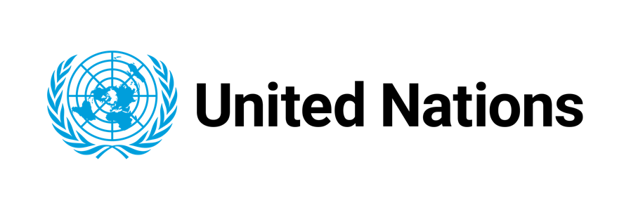
Press Release

UN launches campaign, calling for renewed global ambition and action for the Sustainable Development Goals

Public mobilization comes ahead of critical halftime Summit in September at UN in New York

New York, 5 July 2023 - The United Nations, today, is kicking off a communications campaign to rally for the Sustainable Development Goals (SDGs), the roadmap for people and planet adopted by world leaders in 2015. Ahead of a critical UN Summit in September, the campaign aims to amplify an urgent call for ambitious new action, showcase the Goals as the blueprint for sustainable progress globally, and galvanize the global public around this shared agenda for our common future.

At halftime toward the deadline of 2030, the promise of the SDGs is in peril. For the first time in decades, development progress is reversing under the combined impacts of climate disasters, conflict, economic downturn and lingering COVID-19 effects.

The 2023 SDG Summit will gather world leaders at the United Nations Headquarters in New York on 18-19 September to reaffirm their collective commitments to the Goals and the promise to leave no one behind. This Summit is a defining moment to urgently put the world back on track to achieving the SDGs.

Starting today, in a major digital activation across platforms and countries worldwide, the UN campaign aims to re-energize the conversation about the Goals.

“It is all hands-on-deck in rescuing our SDGs” said Jaap van Hierden, United Nations Resident Coordinator for Micronesia. “In supporting this ambition, the United Nations is working closely with the leaders and people in Micronesia in helping to accelerate development and Leave No One Behind. We do so in close collaboration with our Development Partners and other key stakeholders. Through our inclusive approach, that includes a five year Cooperation Framework for the Pacific and Country Implementation Plans for each of the five Micronesian countries, we hope to catch up in achieving our 2030 SDG targets”.

Building off the color wheel brand of the SDGs, the campaign uses a dynamic new visual system for its messaging to build momentum, raise awareness and mobilize accelerated action for the SDGs.

One core campaign component is the call to individual citizens to take action on the SDGs through the UN’s ActNow initiative across all 17 Goals. From using public transportation, to fundraising for schools or speaking up for equality, the platform lists steps that everyone can take to accelerate progress on the SDGs and create better lives on a healthier planet for all.

A curated group of high-profile influencers, the Circle of Supporters, will galvanize their communities to take individual action on the SDGs and to impress upon decision-makers the urgency to act now.

More information on the SDG Summit is available at: https://www.un.org/en/conferences/SDGSummit2023
Hashtag: #GlobalGoals

Media contact:

Alexandra del Castello, UN Department of Global Communications, alexandra.delcastello@un.org
Zia Ur Rehman, UN Resident Coordinator Office Micronesia, Zia.Urrehman1@un.org

